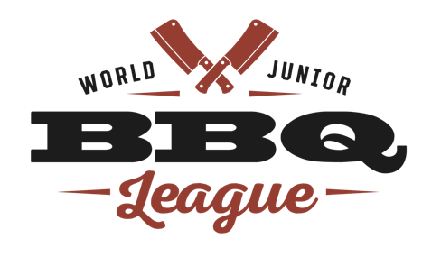

WORLD JUNIOR BBQ LEAGUE CONTEST APPLICATION FORM

Contest Name: _________________________________________________________________

Contest Date: __________________________________________________________________

Contest Address: _______________________________________________________________

City/state/zip:____________________________________________________________

Contest Website:________________________________________________________________

Contest Organizer: _____________________________________________________________

Mailing Address: _______________________________________________________________

City/state/zip:____________________________________________________________

Phone:_______________________________ Email:_________________________________

Judging Chairperson: __________________________________________________________

Mailing Address: _______________________________________________________________

City/state/zip:____________________________________________________________

Phone:_______________________________ Email:_________________________________

Would you like to host a WJBL Certified BBQ Judging Class? ___Yes ___No

By signing below, Contest Organizer hereby applies to receive sanctioning by the WJBL of the above-mentioned contest, certifies that the information provided in this Sanctioning Application is complete, accurate, true and correct, and acknowledges that Organizer has received, read and understands, and agrees to be legally bound by the WJBL Rules and Regulations and Sanctioning Agreement.

____________________________________ _______________________
Signature of Contest Organizer Date

