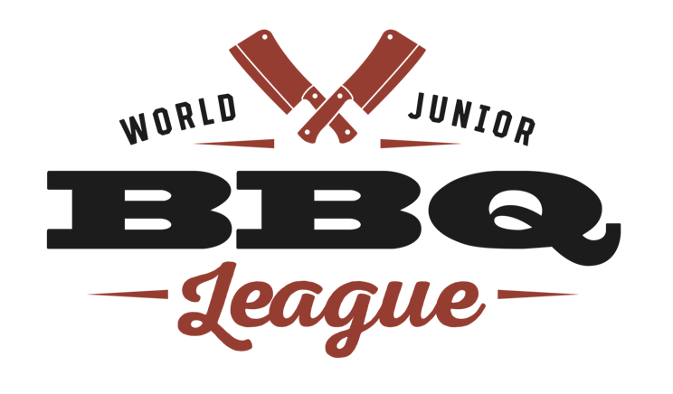

WJBL Sanctioning Agreement

- The organizer agrees to abide by all WJBL rules and regulations and judging procedures at all times.
- Organizer must submit an application with the sanctioning fee for sanctioning to the WJBL and it must be approved before contest is publicized. If the sanctioning is not approved, the fee will be refunded.
- After sanctioning has been approved, organizer is encouraged to use the official WJBL logo on all contest materials promoting event.
- Prize money must be listed on any team applications or website for teams to sign up.
- All prize monies are to be awarded immediately following the completion of the contest at awards. The organizer is responsible for the prize money to be awarded.
- All teams must be members of the WJBL. If they cannot afford membership ($25 per member) we do have scholarships available. This is to ensure that all forms and waivers are completed before contest date.
- All teams/judges must sign up for the contest through the WJBL website.
- Contest entry fees will be issued to the organizer on the day of the contest.
- Organizer must provide the meat for the WJBL contest to put the kids on an even playing field. The meat categories and quantities are chicken thighs (12), loin back ribs (4), pork butts (2) and brisket flats (1) per team entry of that category. Your local grocery stores/meat markets will usually donate meat for kids’ competitions.
- Organizer agrees to provide one free entry as a scholarship for a team designated by the Board of the WJBL.
- WJBL contests start at 5am but teams do set up the night before, organizer agrees to have security in place so that kids do not have to stay overnight.
- WJBL judges are to be used when available. If not available, the representative of the WJBL will make the necessary substitutions.
- The minimum sanctioning fee for a WJBL contest is $250.
- There is a $20 per team administration fee in addition to the sanctioning fee which will be deducted from the entry fees due to the contest.
- Organizer agrees to pay the reps their reimbursement fees at the end of the contest.
- Thirty (30) days prior to the contest date the organizer must provide a Certificate of Insurance for a minimum of $1,000,000/$2,000,000 with the WJBL listed on the certificate as also insured.
- The organizer agrees to provide all judging materials. A list will be sent once sanctioning is approved (i.e. Styrofoam boxes, pencils, crackers, etc)
- Due to the age of our contestants, we do not release our scores. We do give comments from judges at the representatives’ discretion to help the kids learn, therefore, any and all information obtained regarding scoring that is not otherwise ascertained at awards must be held strictly confidential.
- Contest agrees to allow the WJBL use of logo to promote contest on WJBL website.
- It is understood that this agreement does not create a partnership between the contest and the WJBL. The organizer may not contract on behalf of the WJBL. The WJBL will provide organizer with proprietary information which shall not be used for any other purposes other than the contest which is being sanctioned for a one-time event and cannot be shared with others. The organizer is solely responsible for his/her event.
- Any violation of this agreement will, at the sole discretion of the WJBL, terminate the agreement and all monies previously paid will be forfeited.
- Organizer agrees to waive, release, hold harmless and forever discharge WJBL and its officers, representatives, Board of Directors, agents, volunteers, whether past or present or future from any and all responsibility or liability for injuries, damages, costs or losses results from or arising out of the contest.
- Settlement of any disputes will be governed under the laws of the State of Mississippi.

